Performance Task: Step 2
Pre-Assess Student Content Literacy Strengths and Weaknesses

- Create a Content Literacy Pre-Assessment for your students.
- Design an assessment that provides students the opportunity to:
- Read a sample of complex, content-rich nonfiction text in your content area;
- Respond in writing to a prompt that requires them to both summarize and support a statement with evidence and/or reasoning, appropriate to your grade level and content;
- Read and write grade-appropriate academic language.
- Samples of complex, content-rich nonfiction text are available in the Common Core Standards, Appendix B (http://www.corestandards.org/assets/Appendix_B.pdf).
- See samples of Content Literacy Pre-Assessments on pages 3-10 of this document.
- Administer your Content Literacy Pre-Assessment to at least one full class of students. Tell students that you will not be taking anything away from their grade for this assessment, but rather it is to help you do a better job of meeting their needs. Distribute the rubric below, and tell students that this is how you will score their response. Review the rubric with them and be sure they understand it before they begin.
- Score student responses according to this rubric (based on PARCC Rubric for Analytic and Narrative Writing):
Content Literacy Pre-Assessment Rubric
 | 4 | 3 | 2 | 1 | 0
Accuracy of requested summary of paragraph | Addresses prompt and provides complete, effective summary showing full comprehension of complex ideas expressed in text. | Addresses prompt and provides effective summary showing comprehension of complex ideas expressed in text. | Addresses prompt and provides minimal, but accurate summary of text. | Provides accurate description at least 1 main idea. | Provides inaccurate summary, or summary is under-developed, or student does not provide summary.
Quality of evidence and/or reasoning | Uses clear and convincing reasoning, details, text-based evidence, and/or description. | Uses clear reasoning, details, text-based evidence, and/or description. | Uses some reasoning, details, text-based evidence, and/or description. | Uses minimal but appropriate reasoning, details, text-based evidence, and/or description. | Provides no evidence reasoning.

- Using a copy of the rubric, make a summary of student scores by indicating the number/percentage at each score point, like this:
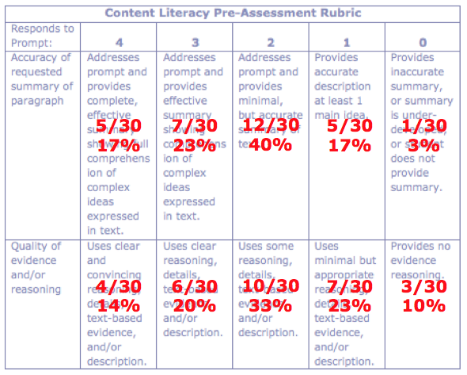
- Go on to Step 3.

Page 1
Sample Content Literacy Pre-Assessment
History, Grades 6-8
(Text excerpt from Common Core Appendix b, page 93).

Directions:
Read the text excerpt below, then write a response to the prompts that follow it. Respond using your best writing. Your response will be scored according to the rubric on the back of this page.

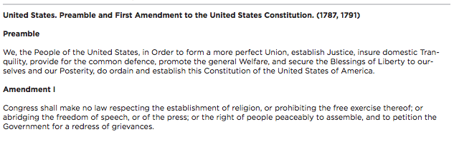

Prompts:
- Briefly summarize the main ideas of the excerpt. Use academic language as appropriate.
- How do the rights listed in Amendment 1 support the goals listed in the Preamble? Use reasoning, details, text-based evidence, and/or description to support your claim.
Take time to prepare your response, sketching out an outline if you prefer.

Page 2

Your response to the Content Literacy Pre-Assessment will be scored according to the rubric below.

Content Literacy Pre-Assessment Rubric
Responds to Prompt: | 4 | 3 | 2 | 1 | 0
Accuracy of requested summary of paragraph | Addresses prompt and provides complete, effective summary showing full comprehension of complex ideas expressed in text. | Addresses prompt and provides effective summary showing comprehension of complex ideas expressed in text. | Addresses prompt and provides minimal, but accurate summary of text. | Provides accurate description at least 1 main idea. | Provides inaccurate summary, or summary is under-developed, or student does not provide summary.
Quality of evidence and/or reasoning | Uses clear and convincing reasoning, details, text-based evidence, and/or description. | Uses clear reasoning, details, text-based evidence, and/or description. | Uses some reasoning, details, text-based evidence, and/or description. | Uses minimal but appropriate reasoning, details, text-based evidence, and/or description. | Provides no evidence reasoning.

Page 1
Sample Content Literacy Pre-Assessment
Science/Math/Technical Subjects, Grades 6-8
(Text excerpt from Common Core Appendix b, page 96).

Directions:
Read the text excerpt below, then write a response to the prompts that follow it. Respond using your best writing. Your response will be scored according to the rubric on the back of this page.

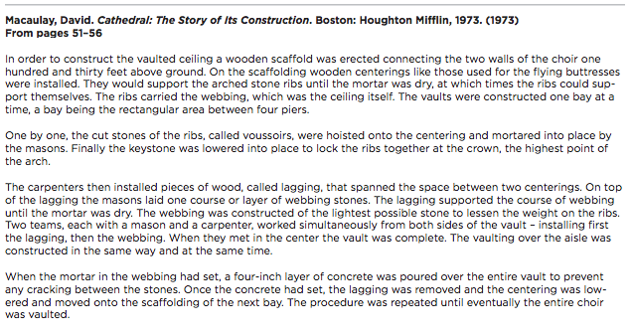
Prompts:
- Briefly summarize the main ideas of the excerpt. Use academic language as appropriate.
- The excerpt describes a complex process of building used in the Middle Ages. How do you suppose that method might have been developed in that time, before most of the common tools of our times? Use reasoning, details, text-based evidence, and/or description to support your claim.
Take time to prepare your response, sketching out an outline if you prefer.

Page 2

Your response to the Content Literacy Pre-Assessment will be scored according to the rubric below.

Content Literacy Pre-Assessment Rubric
Responds to Prompt: | 4 | 3 | 2 | 1 | 0
Accuracy of requested summary of paragraph | Addresses prompt and provides complete, effective summary showing full comprehension of complex ideas expressed in text. | Addresses prompt and provides effective summary showing comprehension of complex ideas expressed in text. | Addresses prompt and provides minimal, but accurate summary of text. | Provides accurate description at least 1 main idea. | Provides inaccurate summary, or summary is under-developed, or student does not provide summary.
Quality of evidence and/or reasoning | Uses clear and convincing reasoning, details, text-based evidence, and/or description. | Uses clear reasoning, details, text-based evidence, and/or description. | Uses some reasoning, details, text-based evidence, and/or description. | Uses minimal but appropriate reasoning, details, text-based evidence, and/or description. | Provides no evidence reasoning.

Page 1
Sample Content Literacy Pre-Assessment
History, Grades 9-10
(Text excerpt from Common Core Appendix b, page 130).

Directions:
Read the text excerpt below, then write a response to the prompts that follow it. Respond using your best writing. Your response will be scored according to the rubric on the back of this page.

Prompts:
- Briefly summarize the main ideas of the excerpt. Use academic language as appropriate.
- Why might have been the U.S. Government’s reasons for creating a “permanent Indian frontier”? What are some flaws with that decision? Use reasoning, details, text-based evidence, and/or description to support your claim.
Take time to prepare your response, sketching out an outline if you prefer.

Page 2

Your response to the Content Literacy Pre-Assessment will be scored according to the rubric below.

Content Literacy Pre-Assessment Rubric
Responds to Prompt: | 4 | 3 | 2 | 1 | 0
Accuracy of requested summary of paragraph | Addresses prompt and provides complete, effective summary showing full comprehension of complex ideas expressed in text. | Addresses prompt and provides effective summary showing comprehension of complex ideas expressed in text. | Addresses prompt and provides minimal, but accurate summary of text. | Provides accurate description at least 1 main idea. | Provides inaccurate summary, or summary is under-developed, or student does not provide summary.
Quality of evidence and/or reasoning | Uses clear and convincing reasoning, details, text-based evidence, and/or description. | Uses clear reasoning, details, text-based evidence, and/or description. | Uses some reasoning, details, text-based evidence, and/or description. | Uses minimal but appropriate reasoning, details, text-based evidence, and/or description. | Provides no evidence reasoning.

Page 1
Sample Content Literacy Pre-Assessment
Science/Math/Technical Subjects, Grades 9-10
(Text excerpt from Common Core Appendix b, page 136).

Directions:
Read the text excerpt below, then write a response to the prompts that follow it. Respond using your best writing. Your response will be scored according to the rubric on the back of this page.

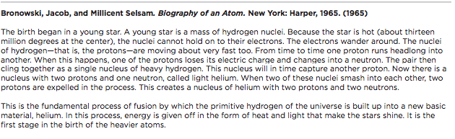

Prompts:
- Briefly summarize the main ideas of the excerpt. Use academic language as appropriate.
- Why might have been the U.S. Government’s reasons for creating a “permanent Indian frontier”? What are some flaws with that decision? Use reasoning, details, text-based evidence, and/or description to support your claim.
Take time to prepare your response, sketching out an outline if you prefer.

Page 2

Your response to the Content Literacy Pre-Assessment will be scored according to the rubric below.

Content Literacy Pre-Assessment Rubric
Responds to Prompt: | 4 | 3 | 2 | 1 | 0
Accuracy of requested summary of paragraph | Addresses prompt and provides complete, effective summary showing full comprehension of complex ideas expressed in text. | Addresses prompt and provides effective summary showing comprehension of complex ideas expressed in text. | Addresses prompt and provides minimal, but accurate summary of text. | Provides accurate description at least 1 main idea. | Provides inaccurate summary, or summary is under-developed, or student does not provide summary.
Quality of evidence and/or reasoning | Uses clear and convincing reasoning, details, text-based evidence, and/or description. | Uses clear reasoning, details, text-based evidence, and/or description. | Uses some reasoning, details, text-based evidence, and/or description. | Uses minimal but appropriate reasoning, details, text-based evidence, and/or description. | Provides no evidence reasoning.

